Software Design Document


Project Title
AgroSphere – Smart Agricultural Support & Sustainable Solution

Submitted by
Sheraz Rafiq (F22BINFT1M01083)
Muhammad Naveed (F22BINFT1M01112)

Submitted to
Dr. Musarat Karim

Department of Information Technology
Faculty of Computing
The Islamia University of Bahawalpur

Summary
This Software Design Document (SDD) describes the architectural and detailed design of AgroSphere, a web-based agricultural support platform. The system is designed to help farmers diagnose crop diseases using AI, connect with certified field officers, access genuine pesticide products, book solar irrigation services, and participate in agricultural events.
The document explains the overall system architecture, major components, data models, and user interface design. The goal of this SDD is to provide a clear and easy-tounderstand blueprint for developers, evaluators, and stakeholders, ensuring that all important concepts from the SRS are properly transformed into a logical and implementable design.

Table of Contents
- Application Architecture

- Architectural Pattern (MVC)

- System Components

- API and External Services

- UML Diagrams (Conceptual)

- Coding Conventions

- Data Model Schema

- Entity Relationship Description

- User Interface Design

1. Application Architecture
AgroSphere follows a three-tier web architecture consisting of:
- Presentation Layer (Frontend)

- Application Layer (Backend / Business Logic)

- Data Layer (Database & AI Models)
The architecture ensures scalability, maintainability, and separation of concerns.

High-Level Architecture Flow
- User interacts with the web interface
- Requests are sent to backend APIs
- Business logic processes the request
- Data is fetched/stored in database
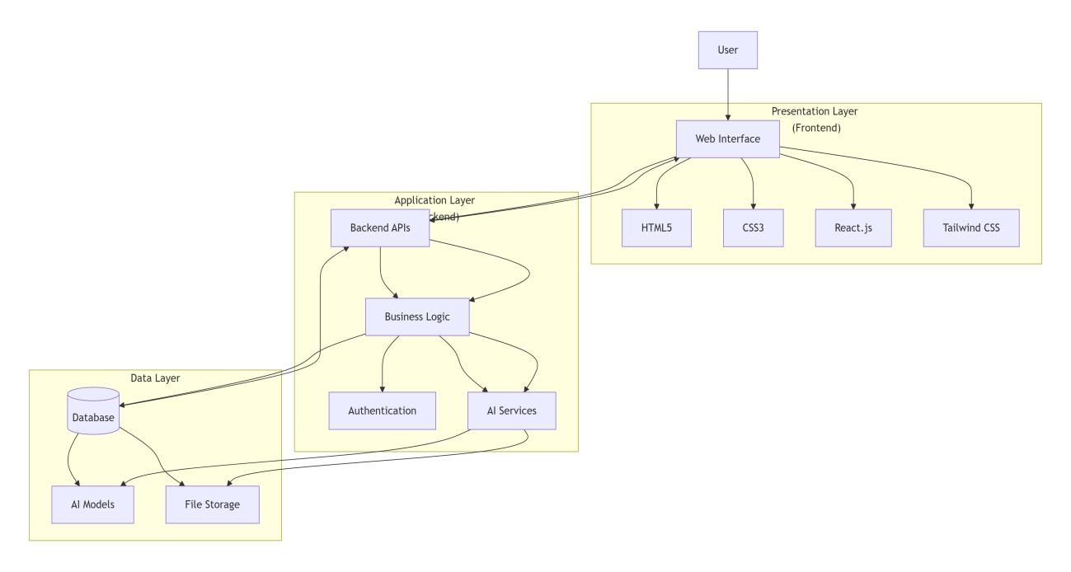
•

AI services analyze crop images

•

Response is returned to the user

2. Architectural Pattern (MVC)
AgroSphere uses the Model–View–Controller (MVC) architectural pattern.

Model
- Handles data structure and database interaction
- Represents entities such as Users, Crops, Products, Services, and Events

View
- User interface developed using React.js
- Displays dashboards, forms, listings, and reports

Controller
- Manages communication between Model and View
- Handles requests, validations, and responses
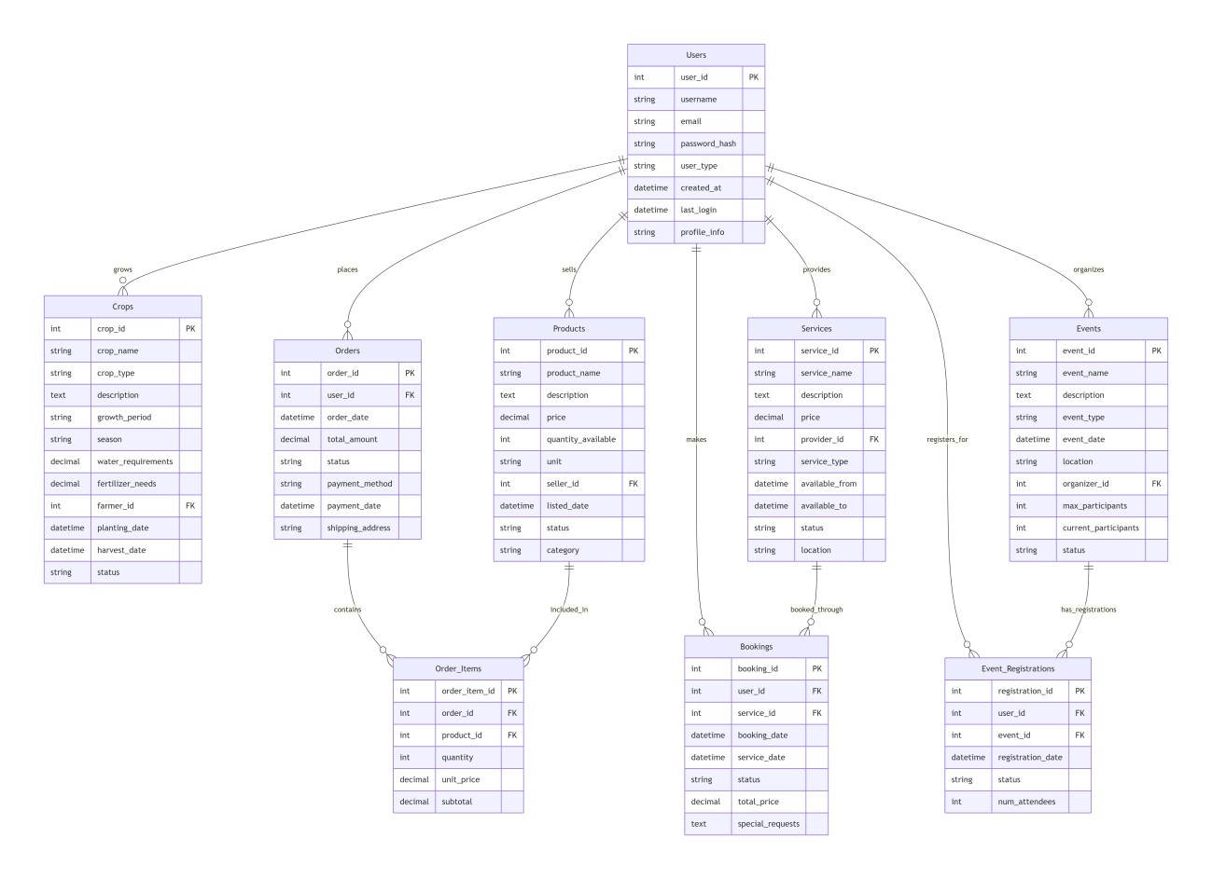

3
. System Components

3.1 Controllers
Authentication Controller
- User registration
- Login and logout
- Role-based access control
Crop Diagnosis Controller
- Upload crop images
- Send images to AI engine
- Store diagnosis results
- Notify field officers if needed
Product Marketplace Controller
- Add and manage products
- Search and filter products
- Product comparison
- Company–farmer communication
Solar Service Controller
- Submit service requests
- Manage quotations
- Schedule services
- Store ratings and feedback
Event Management Controller
- Create and update events
- Event registration
- Notifications and reminders
Admin Controller
- Approve users
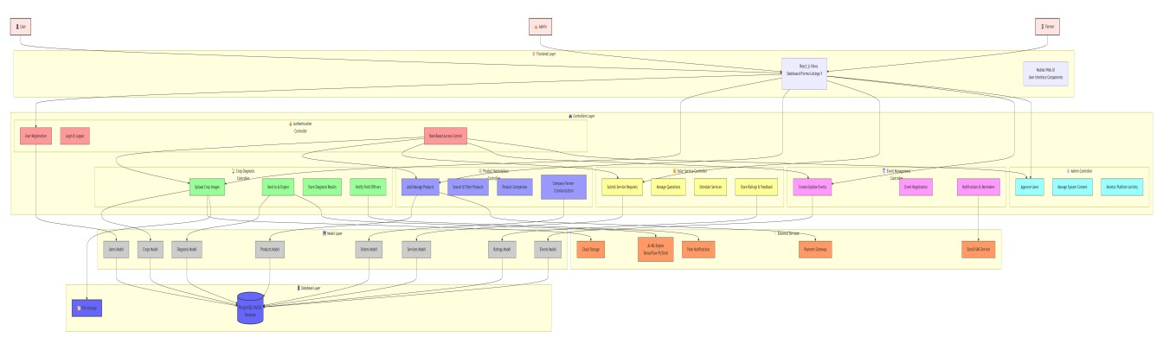
•

Manage system content

•

Monitor platform activity

4. API and External Services

Internal APIs
- /api/register
- /api/login
- /api/diagnose-crop
- /api/products
- /api/solar-services
- /api/events

External Services
AI Crop Diagnosis API
- Built using TensorFlow / PyTorch
- Takes crop image as input
- Returns disease name, confidence score, and recommendations Cloud Services
- AWS S3 / Firebase for image storage
- Email & notification services

5. UML Diagrams (Conceptual)

Use Case Diagram (Textual Description)
Actors: - Farmer - Field Officer - Pesticide Company - Solar Installer - Admin
Main Use Cases: - User Registration - Crop Disease Diagnosis - Product Comparison - Solar Service Booking - Event Registration

Sequence Diagram (Example: Crop Diagnosis)
- Farmer uploads image
- Controller sends image to AI module
- AI analyzes image
- Result returned
- If confidence low → Field Officer notified
- Final response shown to farmer

6. System Flow Diagrams
The following flow diagrams explain the step-by-step working of major system modules in an easy and understandable way.

6.1 User Registration Flow
Start → User opens registration page
→ Selects role (Farmer / Company / Installer / Officer)
→ Enters required details
→ Submits registration form
→ Admin reviews request
→ If approved → Account activated
→ User redirected to dashboard
→ End
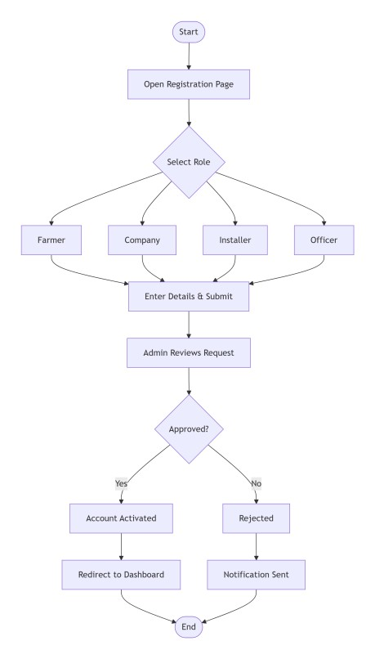

6.2
AI Crop Disease Diagnosis Flow

Start
→ Farmer logs in
→ Uploads crop image + symptoms
→ Image sent to AI model
→ AI analyzes image
→ Is confidence score high? - Yes → Show diagnosis & recommendations to farmer
- No → Notify field officer
→ Field officer reviews case
→ Final diagnosis sent to farmer
→ End
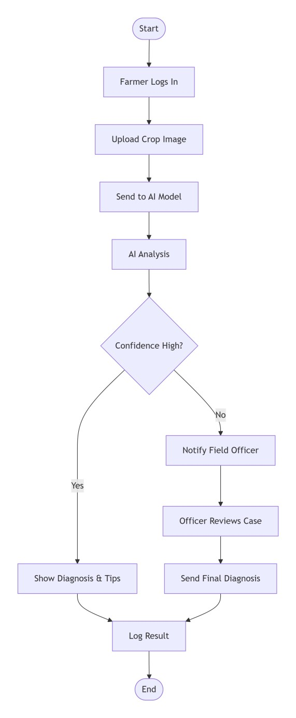

6.3
Product Marketplace Flow

Start
→ Farmer logs in
→ Views product marketplace
→ Searches / filters products
→ Compares products
→ Selects product
→ Contacts pesticide company → Negotiation / inquiry
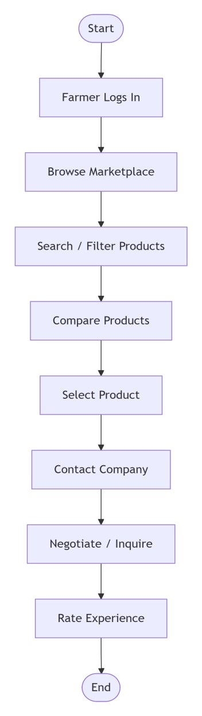
→ Farmer rates experience

→ End

6.4 Solar Service Booking Flow
Start
→ Farmer logs in
→ Submits solar service request
→ Installer receives request
→ Installer sends quotation
→ Farmer accepts or rejects offer
→ If accepted → Service scheduled
→ Service completed
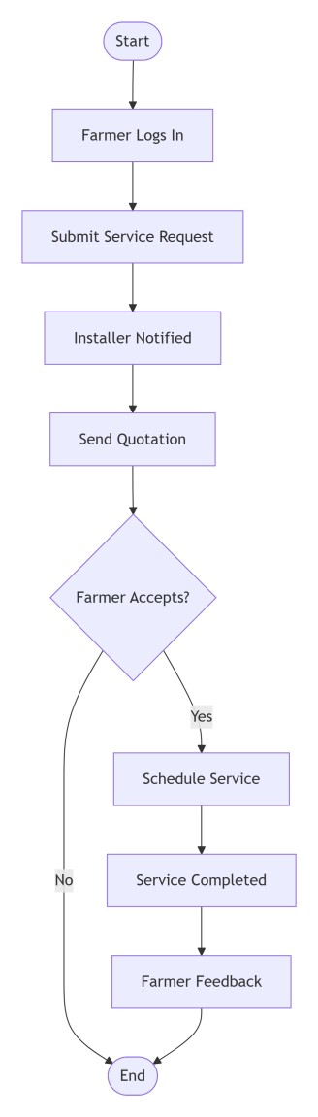
→ Farmer provides feedback

→ End

6.5 Event Management Flow
Start
→ Company/Admin creates event
→ Event published on platform
→ Farmer views event
→ Registers for event
→ Notification sent
→ Farmer attends event
→ Feedback submitted
→ End
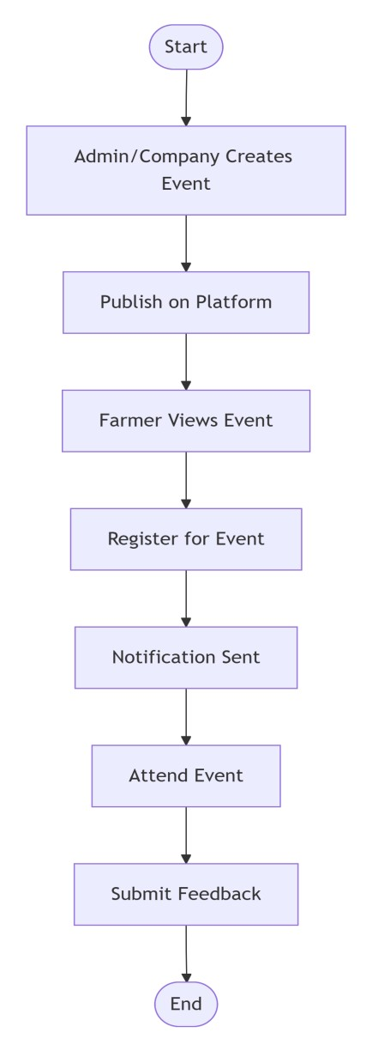

6
. Coding Conventions

- CamelCase for variables and functions
- Meaningful class and function names
- RESTful API naming standards
- Modular and reusable components
- Proper comments for complex logic

7. Data Model Schema

User Entity
- UserID (PK)
- Name
- Email
- Password
- Role (Farmer, Admin, Company, Installer, Officer)
- Status

CropDiagnosis Entity
- DiagnosisID (PK)
- UserID (FK)
- ImagePath
- DiseaseName
- ConfidenceScore
- Recommendation
- Date

Product Entity
- ProductID (PK)
- CompanyID (FK)
- ProductName
- Description
- Price
- Availability

Solar Service Entity
- ServiceID (PK)
- FarmerID (FK)
- InstallerID (FK)
- ServiceType
- Location
- Status

Event Entity
- EventID (PK)
- Title
- Description
- Date
- Organizer

8. Entity Relationship Description
- One User can have multiple Crop Diagnoses
- One Company can list many Products
- One Farmer can request many Solar Services
- One Event can have many Registrations
(ER Diagram can be added graphically in final submission)

9. User Interface Design

Design Philosophy
- Simple and farmer-friendly UI
- Green and earthy color scheme
- Responsive design for desktop and mobile
- Multilingual support Main Screens
Login / Registration Page
- Textboxes: Name, Email, Password
- Dropdown: Role selection
- Button: Register / Login
Farmer Dashboard
- Upload crop image
- View diagnosis history
- Browse products
- Request solar services
- View events
Company Dashboard
- Manage products
- View farmer inquiries
Admin Dashboard
- Approve users
- Manage platform data

Input Constraints
- Image size limit
- Mandatory fields validation
- Role-based screen access

